**DAILY ONLINE ACTIVITIES SUMMARY**

|  |  |  |  |  |  |  |  |  |
| --- | --- | --- | --- | --- | --- | --- | --- | --- |
| Date: | 05/06/2020 | | | | | Name: | Jyothi B R | |
| Sem & Sec | IV-A | | | | | USN: | 4AL18CS030 | |
| Online Test Summary | | | | | | | | |
| Subject | | ----- | | | | | | |
| Max. Marks | | -- | | Score | | | -- | |
| Certification Course Summary | | | | | | | | |
| Course | Programming Essentials in Python | | | | | | | |
| Certificate Provider | | | Cisco Virtual Academy | | Duration | | | 2.5hrs |
| Coding Challenges | | | | | | | | |
| |  |  |  | | --- | --- | --- | | |  | | --- | | Problem Statement: 1: Program to find how many of the input numbers can be written as powers of 2  2: You are given an array of n numbers and q queries. For each query you have to print the floor of the expected value(mean) of the subarray from L to R.  to Year@noreply.github.com, Subscribed  https://mail.google.com/mail/u/1/images/cleardot.gif | |  |   write a java program to read three integer values from the keyboard and find the sum of the values. Declare a variable "sum" of type int and store the result in it. | | | | | | | | |
| Status:Completed | | | | | | | | |
| Uploaded the report in Github | | | | | Yes | | | |
| If yes Repository name | | | | | https://github.com/alvas-education-foundation/jyothi_b_r | | | |
| Uploaded the report in slack | | | | | Yes | | | |

Online Test Details: (Attach the snapshot and briefly write the report for the same)

Certification Course Details: (Attach the snapshot and briefly write the report for the same)

Coding Challenges Details: (Attach the snapshot and briefly write the report for the same)

**ONLINE TEST DETAILS**: - NOT CONDUCTED

CERTIFICATION COURSE DETAILS:

Programming Essentials in Python :

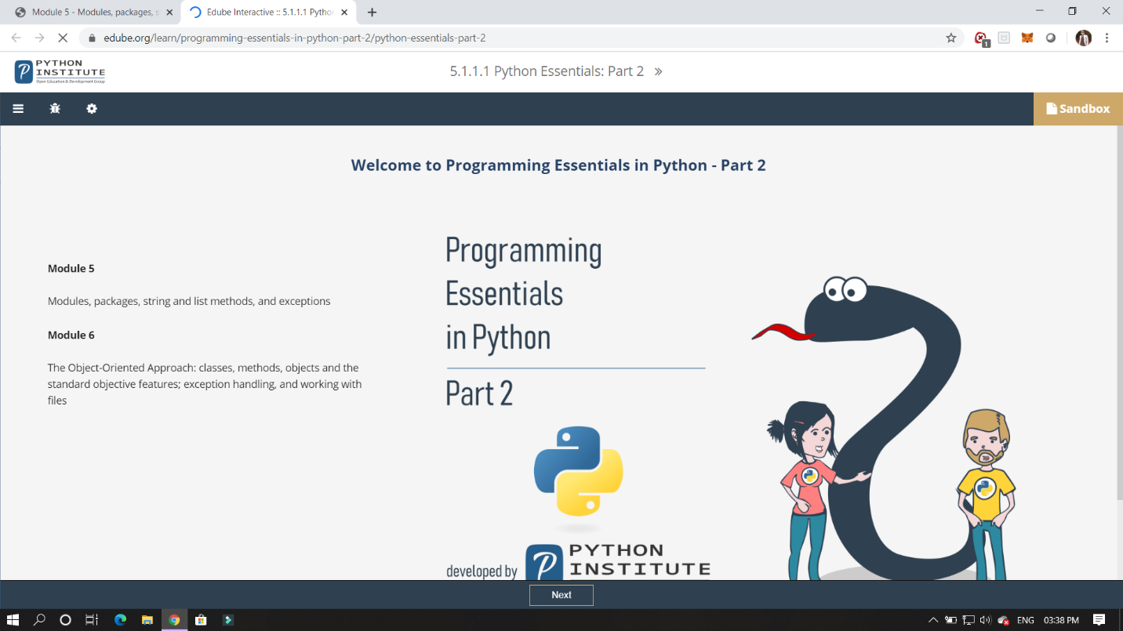

In this module its shows about modules, packages, string and its methods,and exceptions.

ONLINE CODING:

1. (using python) Program to find how many of the input numbers can be written as powers of 2.

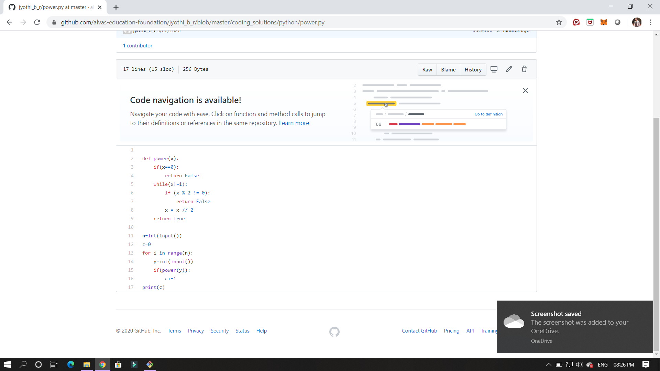

2. : (using Python)You are given an array of n numbers and q queries. For each query you have to print the floor of the expected value(mean) of the subarray from L to R.

